https://www.aljazeera.com/news/liveblog/2026/5/17/iran-war-live-tehran-eyes-tolls-in-hormuz-trump-warns-of-very-bad-time

HEADLINES

Iran war live: Israel attacks Lebanon; drone hits UAE Barakah nuclear site

Iran war live: Israel attacks Lebanon; drone hits UAE Barakah nuclear site
live
This video may contain light patterns or images that could trigger seizures or cause discomfort for people with visual sensitivities.
Al Jazeera Live
By Elis Gjevori, Danai Nesta Kupemba and Urooba Jamal
17 May 2026
Published On 17 May 2026
Save
Share
Click here to share on social media
Add Al Jazeera on Google

- A drone strike has caused a fire at an electrical generator at the Barakah Nuclear Energy Plant in UAE’s al-Dhafra region.
- Israel continues its deadly attacks on southern Lebanon and says it has attacked 100 sites in two days, after negotiators from the two countries agreed to extend a purported “ceasefire” for an additional 45 days.

Read more

86 UpdatesAuto-updates
- 13m ago

(16:00 GMT)

US global power has ‘collapsed’ says Iran’s Defense Ministry spokesperson
Iran’s Defence Ministry spokesman Reza Talaei-Nik has said the US-Israeli war on Iran has shifted the global order.
“In the third imposed war, America’s global hegemony has collapsed. The Iranian nation and armed forces remain ready to respond decisively to any threat or aggression,” he was cited as saying by Iranian semi-official Mehr news agency.
“American unilateralism is reaching its end, and the world, relying on the [February 28, 2026] Ramadan War and the brave resistance and defense of the Iranian nation, is moving toward multilateralism, which will replace American unilateralism.”
- 22m ago

Click here to share on social media
(15:51 GMT)

Trump briefs Netanyahu on Iran and China in phone call
Israeli Prime Minister Benjamin Netanyahu and US President Donald Trump spoke by phone in a call lasting more than half an hour, according to Israeli broadcaster Kan.
The two leaders discussed the possibility of renewed fighting with Iran, while Trump also briefed Netanyahu on his recent visit to China, the report said.
- 28m ago
Click here to share on social media
(15:45 GMT)

WATCH: UAE reports fire at Barakah nuclear facility after drone attack
While the UAE has not blamed anyone for the attack at the Barakah nuclear facility, it begs the question of who is responsible, Natasha Turak, a journalist in Dubai, told Al Jazeera.
“Iran has been silent,” she said, adding the possibility that it could be the Houthis in Yemen who have launched projectiles at the UAE or other proxies. She said because the nuclear facility is so “isolated”, the hit must have been “deliberate”.
Watch the interview below:
4:14
Advertisement
Click here to share on social media

- 35m ago

(15:38 GMT)

Iranian and Qatari ministers discuss ‘regional developments’
Iran Foreign Minister Abbas Araghchi had a call with his Qatari counterpart, Sheikh Mohammed bin Abdulrahman Al Thani.
They “exchanged views on the latest regional developments,” said Iran’s Foreign Ministry.
- 43m ago

Click here to share on social media
(15:30 GMT)

Lebanon ‘losing $30m daily’ in indirect economic damage from Israeli attacks
Lebanon has suffered more than $25bn in direct and indirect losses since Israel’s war on the country started in 2024, according to Bassem El-Bawab, head of the Lebanese Business Association.
El-Bawab said around $12bn will be needed for reconstruction, warning the total could rise further if the conflict continues.
He added that the country is losing about $30m daily in indirect economic damage, alongside the direct destruction of homes, businesses and infrastructure.
- 46m ago

Click here to share on social media
(15:27 GMT)

Israel issues forced displacement orders for villages in south Lebanon
The Israeli military has issued evacuation threats to residents of several villages in southern Lebanon, according to a post on X by its Arabic-language spokesperson Avichay Adraee.
The warning named the villages of Sohmor, Roumine, al-Qusaibah, Houna and Naqoura, urging residents to leave the areas.
- 58m ago

Click here to share on social media
(15:15 GMT)

Qatar condemns ‘reckless’ drone attack in UAE
Qatar has condemned the drone attack near a nuclear plant in the United Arab Emirates.
Posting on X, the Ministry of Foreign Affairs described the attack on the Barakah Nuclear Energy Plant in the al-Dhafra region as a “flagrant violation of international law”, and a “serious threat to regional security and stability”.
The ministry warned that such “reckless attacks” have crossed red lines by targeting critical infrastructure and civilian sites and urged efforts to prevent further escalation.
Qatar also called for de-escalation, stressing the need to avoid the consequences of “unjustified attacks”, and to restore stability at both regional and international levels.
The ministry reaffirmed Doha’s full solidarity with the UAE and its support for measures to protect its sovereignty, security and vital facilities.
- 58m ago
Click here to share on social media

(15:15 GMT)

Jewish settlers cut down 150 fruit and olive trees in West Bank village
Israeli settlers have cut down around 150 fruit trees on land belonging to Palestinian residents in the village of Yasouf, east of Salfit in the occupied West Bank.
Wafa news agency reported that settlers entered the al-Nasba area and destroyed olive, almond, peach and grape trees owned by residents.
The incident comes amid a surge in settler attacks targeting Palestinian land and property in the Salfit area, particularly near settlements and outposts, where residents say the violence aims to force them off their land.
- Get instant alerts and updates based on your interests. Be the first to know when big stories happen.
Click here to share on social media
Yes, keep me updated
- 1h ago
(15:05 GMT)


UAE and IAEA chief discuss drone attack on nuclear plant
UAE Foreign Minister, Abdullah bin Zayed Al Nahyan, and Rafael Grossi have been discussing the nuclear plant drone attack by phone, according to the Emirati state news agency WAM.
We will bring you more as we get it.
Advertisement
Click here to share on social media

- 1h ago

(15:00 GMT)

Netanyahu claims Israel close to eliminating those behind October 7 attacks
Netanyahu says Israel has almost completed a key goal of its war in Gaza, claiming the army has killed all those responsible for orchestrating the October 7 attacks.
His remarks followed the Israeli military’s announcement that Ezzedine Al-Haddad, commander of Hamas’s armed wing, was allegedly killed in an air strike in Gaza on Friday.
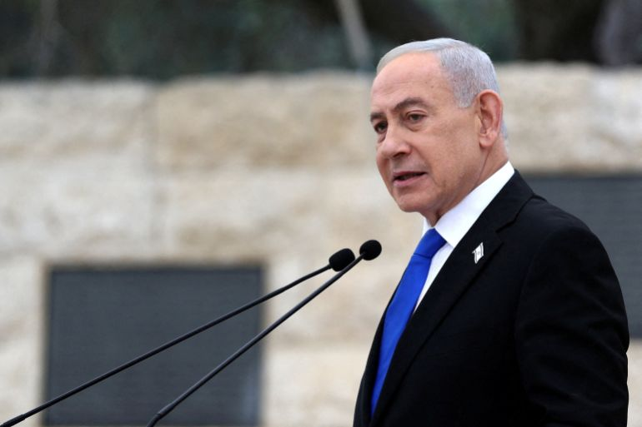Israel’s Prime Minister Benjamin Netanyahu [Ilia Yefimovich/Pool via Reuters]
- 1h ago
Click here to share on social media

(14:45 GMT)

Iran charging ship owners could set a ‘dangerous precedent’
While Iran may try to justify its new maritime framework by comparing it to pre-existing ones such as the Strait of Malacca, the Suez Canal and the Bosporus, the problem with Iran’s framework is that it “discriminates”, says Emma Salisbury, a senior fellow at the Foreign Policy Research Institute.
“The problem with the Iranian plan is that it’s saying it is going to choose which ships go through, that really breaks the freedom of navigation that all these other maritime choke points are under,” she explained.
In response to Iran potentially charging $2m per vessel, she dubbed it as “extortion” and said it would set a “dangerous precedent” for all other chokepoints worldwide.
“Although a lot of them are controlled by liberal democratic countries that are very tuned into the global trade network, there is very much the possibility of non-state actors like the Houthis being able to take over some of those straits, or at least try to, and also extort shipping going through – either you allow extortion or you don’t. This is going to be a big issue,” she said.
- 1h ago
Click here to share on social media

(14:35 GMT)

Iranian president says aim of US-Israel attack was to ‘spread insecurity’ in Iran
President Pezeshkian said the US-Israeli goal in attacking Iran was “to spread insecurity inside the country by supporting terrorist groups”.
In a meeting with Pakistan’s interior minister, he said the plans failed due to the “cooperation and responsibility of Iran’s neighbours in preventing any misuse of their territory against our country [which] was a valuable and commendable act”.
Pezeshkian thanked Pakistan, Iraq and Afghanistan “for not allowing any action against Iran from their soil”, reported the Fars news agency.
- 1h ago

Click here to share on social media
(14:30 GMT)

Targeting UAE’s nuclear facility follows pattern of attack on critical infrastructure
The UAE’s Barakah power plant, hit by a drone attack earlier today, produces about a quarter of the UAE’s total electricity, according to journalist Natasha Turak.
“This plant is not only a major point of pride for the UAE, but also plays a key role in the country’s climate and net-zero by 2050 goals,” Turak told Al Jazeera from Dubai.
“Looking at this drone strike, it’s significant because, if it came from Iran, it follows a pattern of these attacks on the UAE’s critical infrastructure, especially power infrastructure.”
Turak added that this is the first time we’re seeing an attack on the UAE’s nuclear power facilities, as previous attacks focused on oil and gas facilities.
- 1h ago

Click here to share on social media
(14:18 GMT)

UAE says drones enter country from western border
The UAE’s Defence Ministry says three drones have entered the country across its western border with two intercepted and a third hitting a generator outside the inner perimeter of the Barakah Nuclear Energy Plant in the al-Dhafra region, causing a fire.
“Investigations are under way to determine the source of the attacks, and updates will be announced once they are complete,” the ministry said in a post on X.
- 1h ago

Click here to share on social media
(14:15 GMT)

Iran won’t give up control of the Strait of Hormuz without a ‘fight’
Iran’s new maritime protocol shows that they are not going to give up control over the Strait of Hormuz without a “fight”, Emma Salisbury, a senior fellow at the Foreign Policy Research Institute, tells Al Jazeera.
“Iran knows that control of the strait is its big point of leverage because it does have this huge effect on the global economy and oil, fertiliser, gas and all of the things that we all need,” she said.
She explained that if Iran implements the tolls it has suggested, any ship that pays will “fall foul” of the sanctions that are in place against Iran.
“This is a huge commercial risk.”
There are still “considerable risks” from Iran itself, including attacks from sea mines and missiles, although she added that under naval protection there may be “less of a risk”.
- 2h ago
Click here to share on social media

(14:09 GMT)

Lebanon says 2,988 people killed in Israeli attacks since March 2
Lebanon’s Health Ministry says at least 2,988 people have been killed and 9,210 wounded by Israeli attacks since the war escalated on March 2.
- 2h ago
Click here to share on social media
(14:00 GMT)

What we know about the drone attack on UAE nuclear power plant
As we have been reporting, a drone attack earlier today caused a fire at an electrical generator at the Barakah Nuclear Energy Plant in the UAE’s al-Dhafra region.
  - In a post on X, Abu Dhabi’s media office said no injuries were reported and the fire, which broke out outside the plant’s inner perimeter, did not affect radiological safety levels.
  - Emirati officials have not said who they believe is responsible for the attack.
  - The International Atomic Energy Agency said the UAE informed it that radiation levels at the nuclear plant remain normal and no injuries were reported.
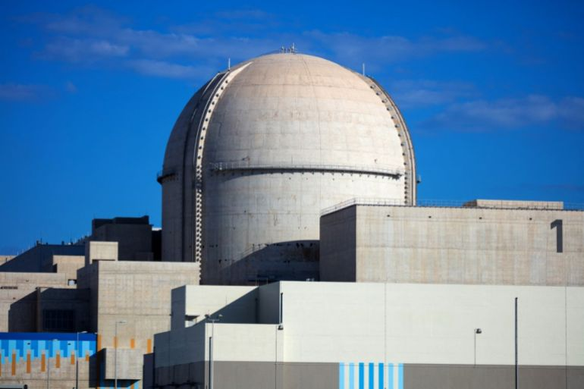The Barakah Nuclear Energy Plant [AFP]
Advertisement
Click here to share on social media

- 2h ago

(13:45 GMT)

The strike that changed the geometry of war
By Nawaf Obaid
On September 9, 2025, Israel struck Qatar.
There was no battlefield, no front line. Instead, the target was a sovereign state hosting negotiations in which Israel itself was involved. When the missiles hit Doha, it set a dangerous precedent.
The Doha strike was a strategic error because it exposed this capability unnecessarily. The target – a meeting of the Hamas leadership convened to review a ceasefire proposal from the Trump administration – was political, not strategic.
Read more here.
- 2h ago
Click here to share on social media

(13:30 GMT)

Israel targeting organisations serving communities across Gaza
By Hind Khoudary
Reporting from Gaza City, Gaza
In the past hour, Israeli forces have targeted a community kitchen affiliated with the Turkish government.
It’s an organisation that has been offering hot meals to a lot of displaced families in Deir el-Balah.
Most of those who are displaced in Deir el-Balah are people who lived in the eastern parts of the city, where they are not allowed to return to their homes, as well as people from Khan Younis and Rafah.
Three workers were killed in this attack, and there were also reports of severe injuries.
Yesterday, there were two Palestinians who were killed as they were travelling in a vehicle very close to al-Shifa Hospital, and those individuals also worked with another organisation called Qawafil Al Khair.
There was a police officer who was killed. This shows that Israel is not only targeting people, but also organisations serving the community across Gaza.
- 2h ago
Click here to share on social media

(13:15 GMT)

Pakistan’s interior minister meets Iran’s president in Tehran
Pakistan’s Interior Minister Mohsin Naqvi has met Iran’s president in Tehran, the Pakistani embassy in Tehran said.
Naqvi, who arrived in Tehran on Saturday, spent nearly three hours at the presidential palace. Iran’s interior minister and foreign minister were also present during the meeting.
- 3h ago

Click here to share on social media
(13:00 GMT)

Iran’s Hormuz control violates international law
Iran’s control over the Strait of Hormuz violates international law and sets a dangerous global precedent, Paul Musgrave, associate professor of politics at Georgetown University in Qatar, told Al Jazeera.
“It quite clearly violates the UN Convention on the Law of the Sea.”
But the implications reach beyond the strait itself.
“The rest of the world has an interest not only in Hormuz, but with every other chokepoint around the world. Imagine Spain making the same declaration about passage in and out of the Mediterranean.”
- 3h ago

Click here to share on social media
(12:45 GMT)

WATCH: Israel’s relentless bombing continues in Lebanon despite ‘ceasefire’ extension
2:24
- 3h ago

Click here to share on social media
(12:30 GMT)

Nations ‘approach’ Iran for Hormuz passage amid oil reserve concerns: Analyst
Countries are approaching Iran to negotiate passage through the Strait of Hormuz, claims Hamidreza Gholamzadeh, director of Tehran’s Diplo House think tank.
“Every single country, despite the rhetoric in place, is coming to Iran and asking for conditions on vessels to go through,” Gholamzadeh told Al Jazeera.
“President Macron has talked to the presidency and has said that France is working with Iran in order to be allowed to use the passage, and is accepting the framework.
“All these countries are running out of strategic oil reserves, and they need to take some action.”
Iran’s position is that it “does not need permission from the Americans” on the question of the strait.
“Iran has to control its own waters, and it is setting up a new framework for that,” Gholamzadeh said.
- 3h ago

Click here to share on social media
(12:20 GMT)

Israel says 4 soldiers injured in southern Lebanon
The Israeli army says one officer and three soldiers were injured in an “explosive device detonation” in southern Lebanon overnight.
- 3h ago
Click here to share on social media

(12:15 GMT)

Latest developments
  - ⁠Netanyahu says he plans to speak to Trump today and expects to hear about the US president’s trip to China and discuss Iran.
  - Three people have been killed in an Israeli drone attack that targeted a community kitchen in Deir el-Balah near Al-Aqsa Martyrs Hospital in central Gaza.
  - A drone attack has caused a fire at an electrical generator at the Barakah Nuclear Energy Plant in the UAE’s al-Dhafra region.
  - One person has been killed in an Israeli strike on a car in the town of Zrarieh in southern Lebanon, the National News Agency reports.
  - South Korean Foreign Minister Cho Hyun has requested Iran’s account of an attack on a South Korean cargo ship near the Strait of Hormuz during a phone conversation with his Iranian counterpart.
- 4h ago
Click here to share on social media

(12:10 GMT)

Israel threatens residents of four towns, villages in Lebanon
Israel has issued new threats for towns and villages in southern Lebanon.
Its spokesperson warned residents in Arzi, al-Marwaniyah, al-Babiliyah, and al-Baysariyah to leave ahead of an attack Israel is threatening.
- 4h ago
Click here to share on social media
(12:00 GMT)

Israeli forces arrest two people, seize their vehicle
Israeli soldiers have arrested two people after assaulting them and seizing their vehicle from the village of Umm Safa, in the occupied West Bank.
Citing local sources, the Palestinian news agency Wafa reported that the young men were taken to the “Atarot” settlement near Umm Safa, northwest of Ramallah.
Advertisement
Click here to share on social media

- 4h ago

(11:45 GMT)

Strikes on UAE continue despite US-Iran ceasefire
Since the US and Iran agreed to a ceasefire on April 8, the UAE has continued to be attacked with drones.
At the start of the war, Iran said it was targeting neighbouring countries because it hosted US military bases and Israeli interests. But the UAE has suffered the brunt of the attacks, worsening relations between the neighbours.
Last week, the UAE accused Iran of launching “a barrage” of missiles and drones at the port of Fujairah. Three Indian nationals were injured and fire was reported at an oil refinery.
The UAE has repeatedly condemned Iranian attacks and reserves the right to respond, including militarily.
- 4h ago

Click here to share on social media
(11:30 GMT)

Tehran is ‘trying to make its control internationally legitimate’
Iran’s reported discussions with European countries over a framework for shipping in the Strait of Hormuz are a strategic choice, Paul Musgrave, associate professor of politics at Georgetown University in Qatar, told Al Jazeera.
“Both Washington and Tehran are trying to change the strategic dialogue, trying to show they both have options beyond the stalemate in the Strait of Hormuz,” he said.
For Iran specifically, the goal is clear: “If your aim is to make sure that you have control over traffic in and out of the Strait of Hormuz, you’d want to display ways that you were trying to make that internationally legitimate”.
The timing, Musgrave said, is significant coming just as Washington used its summit with President Xi to try to “close off Iran’s options”, adding that “there wasn’t a lot of discussion that came out from that meeting between China and the US about what was happening in the strait”.
- 4h ago

Click here to share on social media
(11:25 GMT)

Netanyahu, Trump to speak today
⁠Netanyahu says he is planning to speak to Trump today, adding that he is expected to hear about the US president’s trip to China, as well as discussing Iran.
- 4h ago

Click here to share on social media
(11:15 GMT)

Three killed in Israeli drone attack on community kitchen in Gaza
An Israeli drone attack has targeted a community kitchen in Deir el-Balah, near Al-Aqsa Hospital, killing three people.
Earlier, one person was killed in the Israeli bombing in Khan Younis, southern Gaza.
In Beit Lahiya, one person succumbed to their wounds following an Israeli attack.
- 5h ago

Click here to share on social media
(11:00 GMT)

Israeli drones fly low over Beirut, escalating tensions amid air raids
By Obaida Hitto
Reporting from Tyre
Israel continues to carry out intense air attacks on Lebanon.
It seems Israel is trying to consolidate its positions near the Litani River, especially towards the Marjayoun district and further north into Nabatieh. Over the past week or so, Israel has been pushing very strongly to reach an area north of the Litani River. There haven’t been any confirmed reports of Israel controlling areas there, but there has been an intensification of strikes.
There has also been a significant increase today in the number of drones. They have also been reported flying very low over Beirut. It seems Israel is trying to send a clear message that it will continue to carry out military activities until it considers the situation safe.
- 5h ago

Click here to share on social media
(10:45 GMT)

WATCH: Settler violence empties West Bank village, Palestinians warn of growing displacement
2:42
- 5h ago
Click here to share on social media

(10:30 GMT)

Palestinian casualties mount as Israeli attacks continue despite ‘ceasefire’
The Palestinian Health Ministry in Gaza is reporting six deaths and 19 injuries over the past two days. The death toll includes four bodies recovered from the rubble.
It added that several victims remain under debris or on roadsides, with ambulance and civil defence crews unable to reach them.
Since the latest “ceasefire” began on October 11, 2025, the ministry has recorded 871 deaths in Israeli attacks.
- 5h ago

Click here to share on social media
(10:18 GMT)

Drone strike causes fire at nuclear power plant in Abu Dhabi
A drone strike has caused a fire at an electrical generator at the Barakah Nuclear Energy Plant in the UAE’s al-Dhafra region.
In a post on X, Abu Dhabi’s media office said no injuries were reported and there was no impact on radiological safety levels after the fire outside the inner perimeter of the power plant.

This content is unavailable due to your cookie settings.
To continue, please allow functional cookies from third-party platforms.
AllowManage cookie preferences
- 5h ago

Click here to share on social media
(10:15 GMT)

South Korea seeks Iran’s explanation for ship attack near Strait of Hormuz
South Korean Foreign Minister Cho Hyun has requested Iran’s account of an attack on a South Korean cargo ship near the Strait of Hormuz during a telephone conversation with his Iranian counterpart, Abbas Araghchi.
A South Korean official previously said it was unlikely that any actor other than Iran was behind the attack.
- 6h ago

Click here to share on social media
(10:05 GMT)

One person killed in Israeli attack on southern Lebanon
One person has been killed after an Israeli strike on a car in the town of Zrarieh, NNA reported.
Israeli attacks have continued this morning, with NNA reporting that jets raided the towns of Majdal Selem and Barashit.
- 6h ago

Click here to share on social media
(10:00 GMT)

Lebanon’s economic crisis due to ‘terrible mismanagement’ since 2019
Lebanon entered the current war on a deeply vulnerable economic footing, and that vulnerability was man-made, according to Sami Zoughaib of the Policy Initiative.
The 2019 financial crisis, he said, “was terribly mismanaged”.
“A lot of people benefitted from that crisis, and many of them were from the political class itself,” Zoughaib told Al Jazeera from Beirut, adding that the failure to address the crisis appropriately had left Lebanon unable to absorb the shocks that followed.
“Even if the war in Lebanon stops, the global oil crisis will not, and that is one of the major shocks genuinely impeding Lebanon’s ability to recover in the medium term.”
- 6h ago
Click here to share on social media
(09:45 GMT)

One person killed in Beit Lahiya in Israeli attack
One Palestinian has died after being wounded in an Israeli attack in Beit Lahiya in northern Gaza, Wafa reports.
Earlier, one person was killed and a number were wounded when Israel targeted the centre of Khan Younis in another of its attacks across the enclave today.
Advertisement
Click here to share on social media

- 6h ago

(09:30 GMT)

Photos: Smoke rises as Israel carries out attacks across southern Lebanon
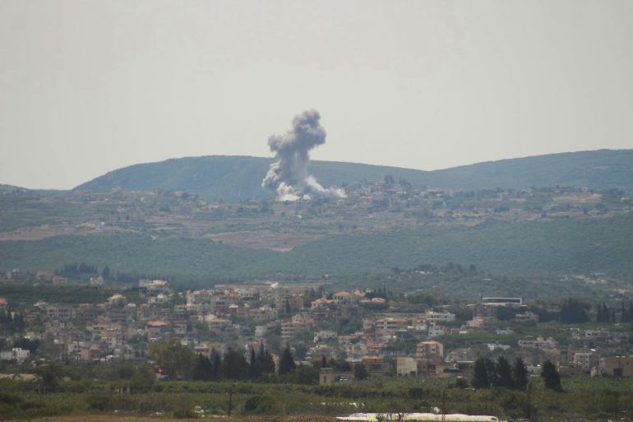Smoke rises from an Israeli air strike on the village of Zibqin on May 17, 2026 (AFP)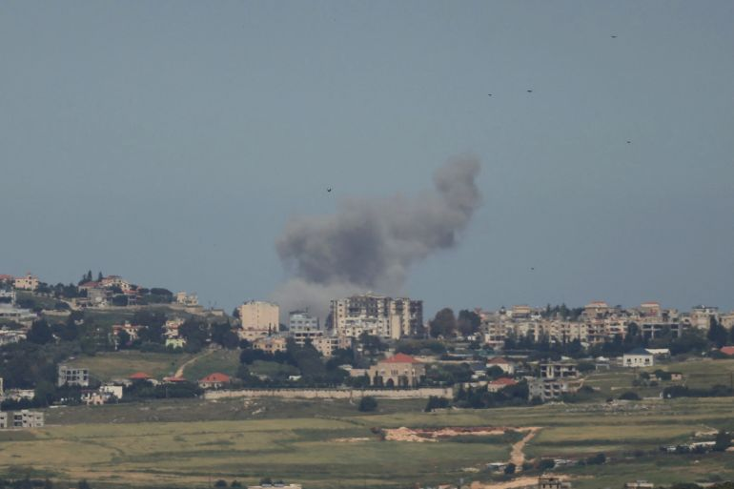[AFP][AFP]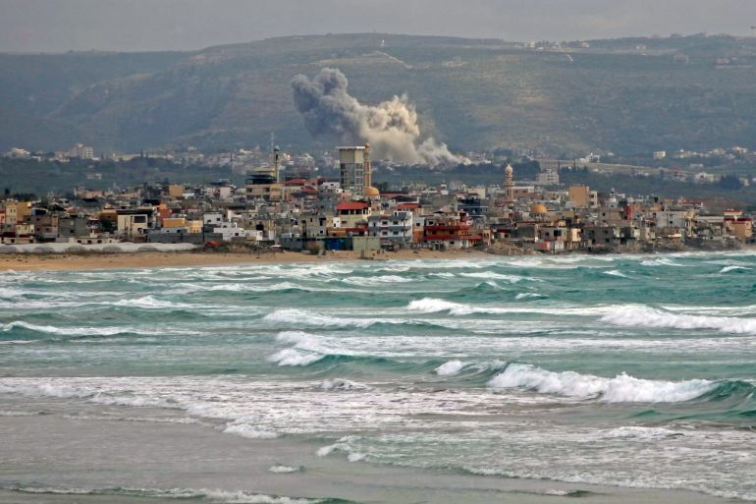[AFP]
- 6h ago

Click here to share on social media
(09:15 GMT)

Lebanon’s recovery ’10 times more difficult’ due to multiple crises and shocks
Lebanon has not recovered from its 2019 financial crisis, and each subsequent shock has made recovery harder, economist Sami Zoughaib of the Policy Initiative tells Al Jazeera.
The current war comes only 15 months after the previous conflict ended.
“These shocks … make this whole situation 10 times more difficult,” he said from Beirut.
People in Lebanon are feeling the pressure through two channels, Zoughaib said, starting with jobs.
“The ability of producers in Lebanon to keep producing has been challenged by rising fuel costs and by the destruction and damage [caused] by the war,” he said, adding that many people find themselves without income.
The second is inflation. Consumer goods prices have risen by an estimated 20 to 25 percent, he said, at a time when “a majority of the Lebanese population was already in some form of income poverty”.
The situation is most acute, he added, for the displaced, those who “currently do not really have a place to go”.
- 6h ago
Click here to share on social media

(09:15 GMT)

Iran’s parliament speaker appointed special envoy to China
Iranian Consultative Assembly Speaker Mohammad Bagher Ghalibaf has been appointed special envoy to China, the state news agency Tasnim reports.
Since the outbreak of the war, Ghalibaf has emerged as one of the chief negotiators in talks with the US aimed at ending the conflict.
- 7h ago

Click here to share on social media
(09:00 GMT)

WATCH: How Israel’s war on Lebanon is pushing its fragile economy to breaking point
2:25
- 7h ago
Click here to share on social media

(08:45 GMT)

US ends temporary waiver on Russian oil sanctions, raising fears of tighter supplies, price hikes
The US Treasury Department has ended a temporary waiver on Russian oil sanctions after its official expiration on Saturday, cutting off a monthlong exemption for global buyers to purchase Russian crude stranded at sea.
The Trump administration initially introduced the emergency waiver to stabilise global energy markets after severe supply shocks.
US and Israeli strikes on Iran triggered the closure of the critical Strait of Hormuz, leading to a spike in global fuel prices. The temporary suspension allowed major consumers, particularly India, to absorb stranded Russian barrels to prevent a full-blown global energy crisis.
With the waiver now expired, there are fears that global oil supplies will tighten, which could drive fuel prices higher. Major importers like India, which had increased purchases of Russian crude to record highs of 2.3 million barrels per day during the exemption, must now find alternative suppliers.
Experts said this shift is likely to push global energy benchmarks upward and could increase US petrol prices, which are already averaging $4.50 a gallon (3.8 litres). Both domestic and international oil prices have hovered around or above $100 per barrel since the war began.
- 7h ago

Click here to share on social media
(08:30 GMT)

Number of ships transiting Hormuz up, but still below pre-war levels
By Tohid Asadi
Reporting from Bandar Abbas, Iran
Iran says the strait is open to all except its adversaries, and any passage through the trajectory of this significant chokepoint should be coordinated with the Iranian military.
Sources say the number of ships transiting through the strait has slightly increased, but is still very low compared with pre-war times.
Iran also said it is critically important for the US to lift the blockade on Iranian ships as a condition that could be taken into consideration when it comes to taking the Strait of Hormuz into a normal situation.
2:07
- 7h ago

Click here to share on social media
(08:15 GMT)

Iran war day 79: Tehran to unveil Hormuz toll plan; Israel bombs Lebanon
Iran says it will soon reveal its plan to manage traffic ⁠through the Strait of ⁠Hormuz, including the charging of tolls, as Trump warns Tehran it will have a “very bad time” if a peace deal is not reached soon.
On Saturday, Iran’s first vice president said his country will no longer allow “enemy” military equipment to pass through the Strait of Hormuz.
Meanwhile, Israel’s relentless bombardment of southern Lebanon continues with an air attack on the town of Zawtar al-Sharqiyah.
Read more here.
- 8h ago
Click here to share on social media

(08:00 GMT)

What’s going on in the occupied West Bank
Israeli forces have arrested a young man from the northern Jordan Valley as they continue their raids and arrest campaign in the occupied West Bank, Wafa reports.
Here’s what else has happened this morning:
  - Israeli forces arrested two young men from the town of Kobar, north of Ramallah.
  - Two brothers were arrested in the village of Husan, west of Bethlehem.
  - Soldiers stormed the town of Azzun, east of Qalqilya.
  - Settlers stormed the town of Sinjil, northeast of Ramallah, and performed Talmudic rituals at its entrance.
  - Five people were wounded in a settler attack in the village of al-Maniya, southeast of Bethlehem.
- 8h ago
Click here to share on social media

(07:45 GMT)

Lebanon’s economy hit hard as conflict with Israel deepens crisis
Lebanon’s economy has been in crisis for years, long before the latest conflict between Hezbollah and Israel.
The war is making the situation worse. Economy Minister Amer Bisat told Al Jazeera that Lebanon is estimated to have lost up to $2bn dollars since the war escalated on March 2 – roughly 7 percent of its gross domestic product. And reconstruction is expected to cost billions of dollars.
“Lebanon doesn’t have enough resources to help all those impacted by the latest fighting between Hezbollah and Israel,” Al Jazeera’s Zeina Khodr said, reporting from Beirut.
“The government is providing shelter to 120,000 people, but hundreds of thousands more are on their own. When the conflict began, it was still recovering from the war in 2024.”
Bisat said 1.2 million people have been displaced in five weeks.
“The impact has been major – people losing their jobs, farms are not producing, manufacturing companies closing, tourists not showing up.”
- 8h ago

Click here to share on social media
(07:30 GMT)

WATCH: How Israel’s war on Lebanon is pushing its fragile economy to breaking point
Lebanon’s economy has been in crisis for years, long before the latest conflict between Hezbollah and Israel.
The war is making the situation worse.
Economy Minister Amer Bisat told Al Jazeera that Lebanon is estimated to have lost up to $2bn so far.
Watch below:
2:25
- 8h ago
Click here to share on social media

(07:15 GMT)

Kazakhstan sends 30 wagons of aid to Iran
Kazakhstan has delivered 30 wagons of humanitarian aid to Iran, according to Tasnim news agency, as the country continues to grapple with a severe economic crisis following months of war with the US and Israel.
The shipment, sent on the orders of Kazakhstan’s president, included canned meat, sugar, flour, medical equipment and medicine. The aid was handed over to the Iranian Red Crescent Society at the Sarakhs railway station.
Kazakh ambassador to Iran, Ontalap Onalbayev, said at the ceremony that “Iran is one of Kazakhstan’s important political, economic and humanitarian partners in the Middle East and the Islamic world,” adding, “True friends are known in difficult times.”
The delivery comes as Iran faces severe economic strain. War-related disruptions have driven annual inflation to about 53.7 percent, with food prices surging more than 115 percent compared with the previous year, according to Iran’s official statistics centre.
28:00
- 9h ago
Click here to share on social media

(07:10 GMT)

Israel attacks western Bekaa Valley in Lebanon
Two Israeli air strikes have targeted the outskirts of the town of Yahmar in the western Bekaa Valley, eastern Lebanon, our colleagues on the ground have reported.
A new Israeli raid has also been reported on the town of Sahmar in the western Bekaa Valley.
- 9h ago
Click here to share on social media

(07:00 GMT)

Comoros scraps fuel price hikes after deadly protests
The government of Comoros says it has “heard the cries of the Comorian people” and has suspended the fuel price increases that had triggered deadly protests.
Energy Minister Aboubacar Said Anli said President Azali Assoumani has suspended the decrees introducing the higher prices, which took effect on May 9, to allow for talks.
“The goal is to preserve peace,” he said at a news conference.
The unrest followed a strike by transport workers and shopkeepers that paralysed public transportation in the capital, Moroni, after the government raised diesel prices by 46 percent and petrol by 35 percent, citing the surge in global oil prices caused by the US-Israeli war on Iran. Clashes with police killed one person and wounded five, and 39 people were detained, according to authorities.
The heads of the transport workers and merchants unions have announced the end of the strike.
- 9h ago

Click here to share on social media
(06:52 GMT)

One person killed in Israeli attack on Khan Younis
We have more on Israel’s continued attacks across the Gaza Strip.
According to local sources, at least one person was killed and several others wounded in an Israeli attack on a police point in the Karaj Rafah area in the southern city of Khan Younis.
The attacks come a day after Israeli forces killed at least 11 people across the Palestinian territory.
- 9h ago
Click here to share on social media

(06:45 GMT)

Qatari, Saudi FMs discuss US-Iran ceasefire in phone call
Qatar’s Prime Minister and Foreign Minister Sheikh Mohammed bin Abdulrahman bin Jassim Al Thani has held a phone call with Saudi FM Prince Faisal bin Farhan Al Saud, according to a statement from Doha.
The two officials discussed bilateral ties and regional developments, including the ceasefire between the US and Iran, as well as de-escalation efforts, the statement said.
Sheikh Mohammed called on all parties to respond to ongoing mediation efforts to address the roots of the crisis through dialogue, aiming for a sustainable agreement that would prevent renewed escalation.
- 9h ago

Click here to share on social media
(06:30 GMT)

Israeli attacks cost Lebanon an estimated $2bn, minister says
Lebanese Economy Minister Amer Bisat has told Al Jazeera that Lebanon is estimated to have lost up to $2bn due to Israel’s escalation of its war on the country since March 2.
“The impact has been fairly major. We think of them in terms of multiple challenges. One challenge is the economic impact itself, people losing their jobs, farms not producing, manufacturing companies closing [and] tourists not showing up,” he said.
“That impact is very large. We are estimating during the war we lost probably $2bn. That’s roughly 7 percent of the GDP.”
- 9h ago
Click here to share on social media

(06:25 GMT)

Israeli forces attack Gaza City and southern, central areas of enclave
Israeli forces have launched attacks across the Gaza Strip, according to the Wafa news agency.
Artillery fire struck eastern and southern areas of Khan Younis in southern Gaza, it said, quoting local sources. The attacks were carried out during heavy gunfire from military vehicles.
Eastern areas of the Bureij refugee camp in central Gaza were also heavily shelled, causing panic among residents.
In Gaza City, Israeli warships fired towards the coast. No casualties have been reported so far.
- 9h ago

Click here to share on social media
(06:15 GMT)

Israeli defence minister slams European boycotts at Eurovision
Israeli Defence Minister Israel Katz has taken to X to congratulate Israeli performer Noam Bettan for placing second at the Eurovision Song Contest in Vienna and to criticise Spain and other European nations that protested against Israel’s participation in the event.
In a post written both in Hebrew and Spanish, Katz offered congratulations “on behalf of the defence establishment and the soldiers” of the Israeli military, framing Bettan’s second-place finish as a successful response to what he termed an “incitement and defamation campaign” led by Spanish Prime Minister Pedro Sanchez and his international allies.
Spain, a “Big Five” financial contributor to Eurovision, was part of a broadcast boycott with Ireland, the Netherlands, Slovenia and Iceland. Their national public broadcasters refused to air the show or send contestants, objecting to the European Broadcasting Union’s decision to allow Israel to compete after its genocidal war on Gaza.
Amid the boycott and demonstrations from the audience during the live semifinal and final events, Bettan’s song Michelle finished behind the winning entry from Bulgaria.
1:59
- 10h ago

Click here to share on social media
(06:00 GMT)

Israeli military says ‘hostile aircraft’ targeted troops in southern Lebanon
The Israeli military says “a suspicious aerial target” has been identified after sirens sounded in the Misgav Am area in northern Israel.
The aircraft fell near Israeli forces operating in southern Lebanon with no casualties reported, the military said on X.
It added that Hezbollah launched rockets and explosive drones towards Israeli forces operating in southern Lebanon overnight and there were no casualties.
- 10h ago

Click here to share on social media
(05:45 GMT)

WATCH: Spanish foreign minister on Spain’s clash with the Trump administration
Spain has been one of Europe’s most vocal critics of Israel’s genocidal war on Gaza, a stance that has put the Spanish at odds with the US and some of its other allies. The Spaniards have also renewed calls for Europe to reduce its military dependence on the US by reiterating calls for a standing European Union army.
So what does it mean for Madrid’s relationship with Washington and its place among US allies?
This week on UpFront, Redi Tlhabi speaks with Spanish Foreign Minister Jose Manuel Albares about Spain’s foreign policy, its commitment to international law and relationship with the US.
Watch below:
13:24
- 10h ago

Click here to share on social media
(05:30 GMT)

One killed in Comoros amid protests over high fuel prices
AFP is reporting that protests over rising fuel prices in Comoros have turned deadly, with one person killed on Saturday following overnight clashes with police.
A young man was fatally shot at dawn after a group “tried to disarm” officers clearing the streets in Mpage, a town on the island of Anjouan, according to a judge who spoke to the agency anonymously.
The island’s prosecution office confirmed that “a tragic event occurred … that led to the death of one person and injuries to five others”.
The unrest, which has triggered a strike by truckers, shopkeepers and fishermen, began after a government announcement last week of sharp fuel price increases, including 46 percent for diesel, linked to the economic fallout from the US-Israel war on Iran.
- 10h ago

Click here to share on social media
(05:25 GMT)

Hezbollah claims attacks on Israeli soldiers, bulldozers
The Lebanese armed group says its fighters have detonated a booby trap of explosives against a third bulldozer belonging to the Israeli military that was trying to advance from the town of Rashaf to the town of Hadatha in southern Lebanon.
The group added that another booby trap was also detonated by a fourth Israeli bulldozer trying to make the same advance.
Fighters also targeted a gathering of Israeli vehicles and soldiers on the outskirts of the town of Hadatha with a rocket barrage, it said.
- 10h ago

Click here to share on social media
(05:15 GMT)

Russian envoy says US, Israel risk repeating past mistakes if they resume war
We have more from Mikhail Ulyanov, Russia’s representative to international organisations in Vienna.
He responded to a New York Times report that said the US and Israel are preparing for a possible resumption of strikes against Iran.
In a post on X, Ulyanov said that if the reports are accurate, it would suggest the US and Israel “have not learned lessons from their past strategic mistakes”.
The New York Times reported that Trump has not yet made a decision but several options were proposed.
Defense Secretary Pete Hegseth said last week that the US has made plans to “escalate if necessary”.

This content is unavailable due to your cookie settings.
To continue, please allow functional cookies from third-party platforms.
AllowManage cookie preferences
- 11h ago

Click here to share on social media
(05:00 GMT)

If you’re just joining us
Here’s what you need to know:
  - Iran’s First Vice President Mohammad Reza Aref says Tehran will no longer allow “enemy” military equipment to pass through the Strait of Hormuz.
  - Israel’s relentless bombardment of southern Lebanon continues, with an air attack reported on the town of Zawtar al-Sharqiyah.
  - Displaced Lebanese civilians say Israel’s extension of a ceasefire creates “a mockery of us” and that it is a truce only “imposed on the Lebanese state”.
  - The UK says it has deployed a new “low-cost anti-drone system” that will be fitted to RAF Typhoon jets so that they can destroy targets precisely and at a fraction of the price of missiles currently used.
  - Mikhail Ulyanov, the permanent representative of Russia to international organisations in Vienna, has backed China’s call for a permanent ceasefire to reopen the Strait of Hormuz.
- 11h ago

Click here to share on social media
(04:45 GMT)

What does Iran want for the Strait of Hormuz?
As we’ve been reporting, Iran says it will soon unveil its plan to charge tolls for ships passing through the Strait of Hormuz.
It has previously framed the charging of tolls as a way to recoup its wartime losses.
Here’s what we know:
  - Iranian legislator Ebrahim Azizi said the plan involves a “professional mechanism to manage traffic in the Strait of Hormuz along a designated route”.
  - He said “only commercial vessels and parties cooperating with Iran will benefit” from the plan and “fees will be collected” for “specialised services”.
  - Iranian First Vice President Mohammad Reza Aref said the country will not allow “enemy” military equipment to pass through the strait.
  - Ali Nikzad, deputy parliament speaker, said earlier that Iran’s legal regime for the waterway takes into account Tehran’s conditions, the rules of international law and the rights of neighbouring countries.
  - The Islamic Revolutionary Guard Corps (IRGC) has previously unveiled maps showing a new zone of control over the waterway and a safe route for ships to follow through the strait that is closer to its coast than traditional routes.
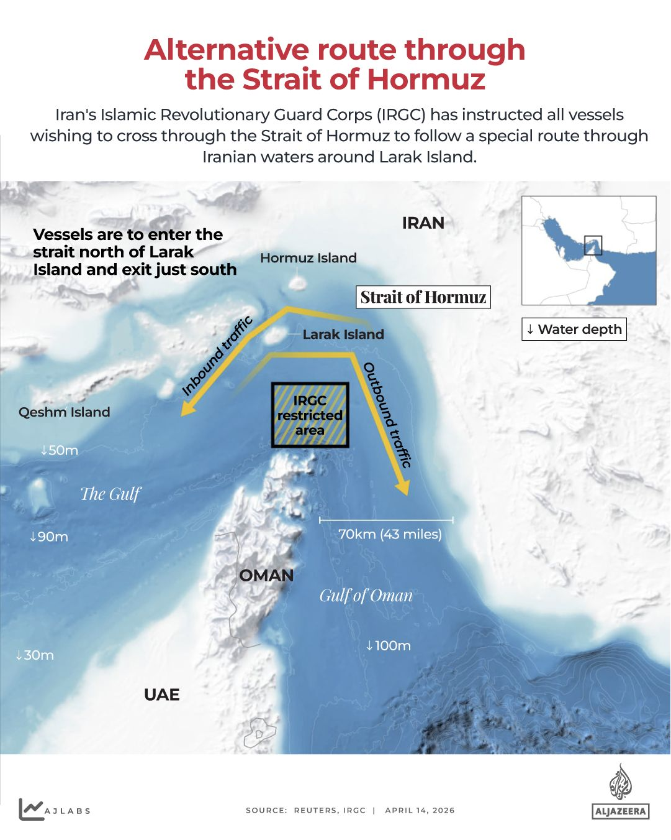
- 11h ago
Click here to share on social media

(04:30 GMT)

‘What kind of truce is this?’
Thousands of Lebanese people remain displaced after Israeli attacks and despite the extension of the purported “ceasefire” by 45 days.
At the Evangelical School in Beirut, some of them shared their views:
“This is not a ceasefire, it’s a mockery of us,” said Ali Salama Abu Hanan, who is displaced from southern Lebanon. “We urge Lebanese officials to take a decisive stance – either put an end to the Israeli aggression against Lebanon, the whole of Lebanon, not just the south, the suburbs, or Beirut, or they should not stop the war. Because this truce is fragile, and at any moment Israel can do as it pleases, with no one to stop it.”
Nawal Mazhar, who is displaced from al-Babliyeh in southern Lebanon, said, “What kind of truce is this? They’re issuing warnings for all the villages, and people are fleeing. What kind of truce is this? Where is the government? We stand only with the resistance – nothing else.”
Ali Hassan Barada, displaced from Hadatha, in the Bint Jbeil district, said there “is no extension of the ceasefire”.
“As you can see, there are martyrs in the south, and the strikes continue there. We are still evacuating the wounded and the martyrs, and there is no ceasefire. The truce is imposed on the Lebanese state.”
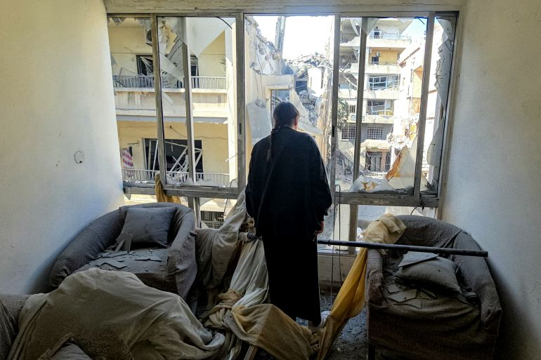A woman looks on from the window of a damaged building following overnight Israeli bombardment on Lebanon’s southern city of Tyre [AFP]
- 11h ago

Click here to share on social media
(04:15 GMT)

WATCH: Francesca Albanese on Israeli sexual violence suffered by Palestinians
A recent New York Times article highlighted the sexual violence suffered by Palestinians at the hands of Israeli forces. But the allegations have been documented for years by human rights groups and Palestinian organisations. So why does the world only seem to pay attention when a Western news organisation does?
This week on UpFront, Redi Tlhabi speaks with UN Special Rapporteur Francesca Albanese about sexual violence, Israeli impunity – and the double standards of Western attention.
Watch below:
- 12h ago

Click here to share on social media
(04:00 GMT)

‘There is zero trust between the two sides’
We have more from Alan Eyre at the Middle East Institute.
The former US negotiator said a deal will not be reached until more trust is built between Washington and Tehran.
“There’s no secret sauce to negotiating with the Iranians. They’re like everyone else. They’re very good at what they do. They know the portfolio. They know the history. They know the details,” he said. “It’s just a question of putting in the time.”
Any deal will take “serious and sustained negotiations”, Eyre said, adding that he doubted if the Trump administration was “willing to roll up its sleeves, lock itself in a room, and spend the time they’re going to need to take to work out a functioning, comprehensive nuclear deal”.
Confidence-building measures were also essential.
“You don’t need full trust. If you had full trust, you wouldn’t need negotiations. You only negotiate with your enemies. But there has to be some trust,” Eyre added.
Iran’s current leadership, which is more hardline and militarised than the government that preceded the war, believes Washington and Israel are ultimately seeking to topple the Islamic Republic, he said, and fears that any pause in hostilities will simply be used to regroup for another strike, perhaps after the midterm elections in the US.
“There is zero trust between the two sides. So you need some type of confidence-building measure just to get some momentum.”
- 12h ago

Click here to share on social media
(03:50 GMT)

Israel bombs southern Lebanon
The Israeli military has carried out an air strike on Zawtar al-Sharqiyah, a town in southern Lebanon, according to our colleagues at Al Jazeera Arabic.
We’ll bring you more when we have it.
- 12h ago
Click here to share on social media

(03:45 GMT)

Photos: Palestinians hold funeral for Qassam Brigades leader in Gaza City
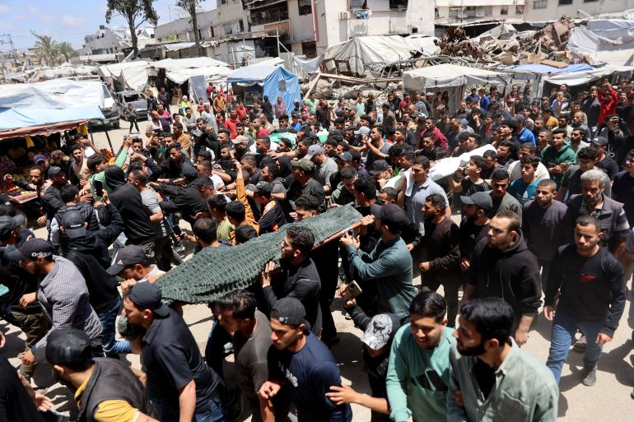Palestinian mourners carry the bodies of Izz al-Din al-Haddad, the slain chief of the Qassam Brigades – the armed wing of Hamas, his wife and daughter, all killed in an overnight Israeli strike, during their funeral in Gaza City [AFP]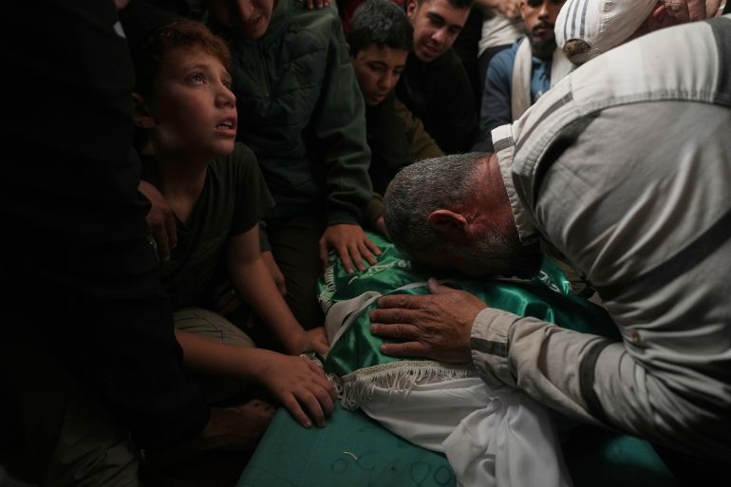[Jehad Alshrafi/AP]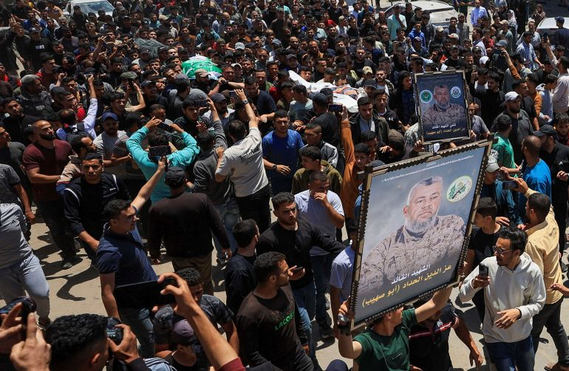[Dawoud Abu Alkas/Reuters]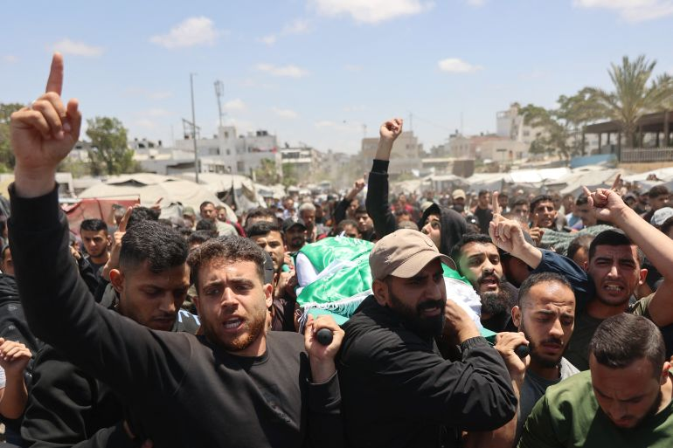[AFP]
- 12h ago
Click here to share on social media

(03:30 GMT)

Russia shares China’s position on Strait of Hormuz, envoy says
Mikhail Ulyanov, the permanent representative of Russia to international organisations in Vienna, has backed China’s call for a permanent ceasefire to reopen the Strait of Hormuz.
“Russia fully shares such an approach,” Ulyanov said in a post on X, referencing Chinese Foreign Minister Wang Yi’s comments.
Wang had said China believes a solution to issues in the Strait of Hormuz “lies in achieving a permanent and comprehensive ceasefire” between Washington and Tehran, and that President Xi Jinping had emphasised in his talks with Trump last week “that force cannot solve problems and dialogue is the only right path”.
The comments came as Bahrain and the US seek support for a resolution at the United Nations demanding Iran stop attacks and laying mines in the Strait of Hormuz.

This content is unavailable due to your cookie settings.
To continue, please allow functional cookies from third-party platforms.
AllowManage cookie preferences
- 12h ago
Click here to share on social media

(03:15 GMT)

Iran says ‘enemy’ weapons shipments will not be allowed to transit Strait of Hormuz
Iran’s First Vice President Mohammad Reza Aref says Tehran will no longer allow “enemy” military equipment to pass through the Strait of Hormuz.

